Quiz 2
Part B Section
Student Id`
Question :1 Kleene’s Theorem
Find closure of give DFA, consider q0 as initial state.
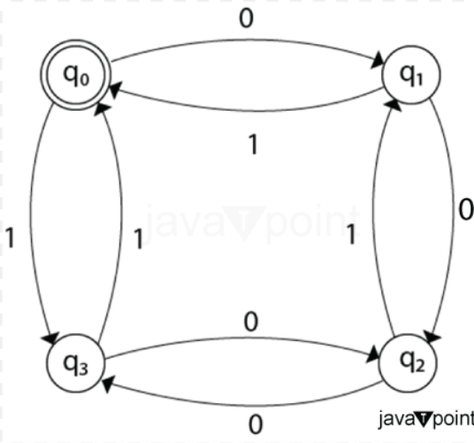
Question :2 Minimized Given DFA.
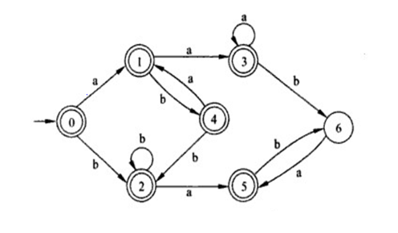
Question 3: RG,CFG
- Write a CFG which generates string having equal no of a’s and b’s.
- 01(1100)^{n} 110 (10)^{n} |n>=0.
- 0^{i} 1^{j} 2^{k} | k<=I or k<=j
- L={a² , a⁵,a⁸…}
- L={a^{n} |n>=0, n !=3}

